{Name of Faith Institution}

CCTV POLICY AND CODE OF PRACTICE
Introduction

Closed circuit television (CCTV) is installed at the premises for the purposes of staff, members, visitors, and premises security. Cameras are located at various places on the premises, and images from the cameras are recorded.

The use of CCTV falls within the scope of the EU General Data Protection Regulation of 2018

In order to comply with the requirements of the GDPR, data must be:

- Fairly and lawfully processed
- Processed for limited purposes and not in any manner incompatible with those purposes
- Adequate, relevant and not excessive
- Accurate
- Not kept for longer than is necessary
- Processed in accordance with individuals' rights
- Secure

Data Protection statement

- [Name of two Trustees/Senior Managers of Faith Institution] are the Data Controllers.
- CCTV is installed for the purpose of staff, members, visitors and premises security.
- Access to stored images will be controlled on a restricted basis within the institution.
- Use of images, including the provision of images to a third party, will be in accordance with the practice’s Data Protection registration.
- CCTV may be used to monitor the movements and activities of staff and visitors whilst on the premises.
- CCTV images may be used where appropriate as part of staff counselling or disciplinary procedures.
- Signage are displayed on the premises stating of the presence of CCTV, and indicating the names of the Data Controllers and a contact number during office hours for enquiries. (see appendix 2 for sample signs).

RETENTION OF IMAGES
Images from cameras are recorded on videotape/disc/computer system (“the recordings”). Where recordings are retained for the purposes of security of staff, members, visitors and premises, these will be held in secure storage, and access controlled.

ACCESS TO IMAGES

It is important that access to, and disclosure of, images recorded by CCTV and similar surveillance equipment is restricted and carefully controlled, not only to ensure that the rights of individuals are preserved, but also to ensure that the chain of evidence remains intact should the images be required for evidential purposes.

Access to recorded images is restricted to the Data Controllers, who will decide whether to allow requests for access by data subjects and/or third parties (see below).

Viewing of images must be documented as follows:

- The name of the person removing from secure storage, or otherwise accessing, the recordings
- The date and time of removal of the recordings
- The name(s) of the person(s) viewing the images (including the names and organisations of any third parties)
- The reason for the viewing
- The outcome, if any, of the viewing
- The date and time of replacement of the recordings

REMOVAL OF IMAGES FOR USE IN LEGAL PROCEEDINGS

In cases where recordings are removed from secure storage for use in legal proceedings, the following must be documented:
- The name of the person removing from secure storage, or otherwise accessing, the recordings
- The date and time of removal of the recordings
- The reason for removal
- Specific authorisation of removal and provision to a third party
- Any crime incident number to which the images may be relevant
- The place to which the recordings will be taken
- The signature of the collecting police officer, where appropriate
- The date and time of replacement into secure storage of the recordings
ACCESS TO IMAGES BY THIRD PARTIES

Requests for access to images will be made using the ‘Application to access to CCTV images’ form (which is at Appendix 1), accompanied by a £10 fee (which is non-refundable if the request is declined).

The data controller will assess applications and decide whether the requested access will be permitted. Release will be specifically authorised. Disclosure of recorded images to third parties will only be made in limited and prescribed circumstances. For example, in cases of the prevention and detection of crime, disclosure to third parties will be limited to the following:

- Law enforcement agencies where the images recorded would assist in a specific criminal enquiry
- Prosecution agencies
- Relevant legal representatives
- The press/media, where it is decided that the public's assistance is needed in order to assist in the identification of victim, witness or perpetrator in relation to a criminal incident. As part of that decision, the wishes of the victim of an incident should be taken into account
- People whose images have been recorded and retained (unless disclosure to the individual would prejudice criminal enquiries or criminal proceedings)
All requests for access or for disclosure should be recorded. If access or disclosure is denied, the reason should be documented as above.

DISCLOSURE OF IMAGES TO THE MEDIA

If it is decided that images will be disclosed to the media (other than in the circumstances outlined above), the images of other individuals must be disguised or blurred so that they are not readily identifiable.
If the CCTV system does not have the facilities to carry out that type of editing, an editing company may need to be used to carry it out.
If an editing company is used, then the data controller must ensure that there is a contractual relationship between them and the editing company, and:

- That the editing company has given appropriate guarantees regarding the security measures they take in relation to the images
- The written contract makes it explicit that the editing company can only use the images in accordance with the instructions of the data controllers
- The written contract makes the security guarantees provided by the editing company explicit

ACCESS BY DATA SUBJECTS

This is a right of access, which is provided by GDPR. Requests for access to images will be made using the ‘Application to access to CCTV images’ form (which is at Appendix 1), accompanied by a £10 fee (non-refundable if the request is declined).

PROCEDURES FOR DEALING WITH AN ACCESS REQUEST

All requests for access by Data Subjects will be dealt with by the Practice Manager.

The data controller will locate the images requested. The data controller will determine whether disclosure to the data subject would entail disclosing images of third parties.
The data controller will need to determine whether the images of third parties are held under a duty of confidence. In all circumstances the practice’s indemnity insurers will be asked to advise on the desirability of releasing any information.

If third party images are not to be disclosed, the data controllers will arrange for the third party images to be disguised or blurred. If the CCTV system does not have the facilities to carry out that type of editing, an editing company may need to be used to carry it out. If an editing company is used, then the data controller must ensure that there is a contractual relationship between them and the editing company, and:

- That the editing company has given appropriate guarantees regarding the security measures they take in relation to the images
- The written contract makes it explicit that the editing company can only use the images in accordance with the instructions of the data controllers
- The written contract makes the security guarantees provided by the editing company explicit
The practice manager will provide a written response to the data subject within 21 days of receiving the request setting out the data controllers’ decision on the request.

A copy of the request and response should be retained.

COMPLAINTS

Complaints must be in writing, and addressed to the practice manager. Where the complainant is a third party, and the complaint or enquiry relates to someone else, the written consent of the patient or data subject is required. All complaints will be acknowledged within 7 days, and a written response issued within 21 days.

APPENDIX 1

DATA PROTECTION ACT - APPLICATION FOR CCTV DATA ACCESS
ALL Sections must be fully completed. Attach a separate sheet if needed.
Name and address of Applicant
Name and address of “Data Subject” – i.e. the person whose image is recorded
If the data subject is not the person making the application, please obtain a signed consent from the data subject opposite | Data Subject signature……………………………….
If it is not possible to obtain the signature of the data subject, please state your reasons.
Please state your reasons for requesting the image.

Date on which the requested image was taken.
Time at which the requested image was taken.
Location of the data subject at time image was taken (i.e. which camera or cameras.)
Full description of the individual, or alternatively, attach to this application a range of photographs to enable the data subject to be identified by the operator.
Please indicate whether you (the applicant) will be satisfied by viewing the image only.

On receipt of a fully completed application and the £10 fee, a response will be provided as soon as possible, and in any event within 40 days. In the event of a declined application the fee is non-refundable.

Institution USE ONLY | Institution USE ONLY
Access granted (tick)
Access not granted (tick) | Reason for not granting access:
Data Controller’s name:

Signature:

Date:

APPENDIX 2

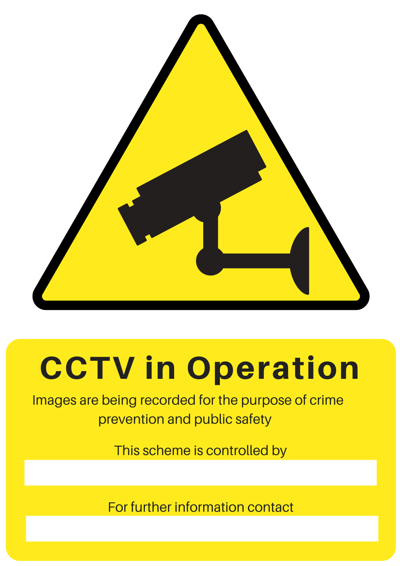
Signage to be displayed on the premises stating presence of CCTV

